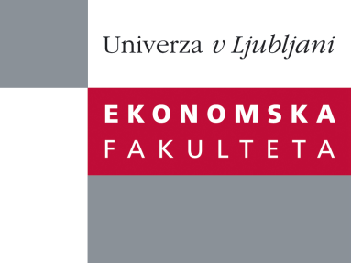

Raziskovalni center Ekonomske fakultete
organizira znanstveno-raziskovalni seminar,
ki bo v sredo, 13. aprila 2011 ob 17 uri
v Sejni sobi dekanata na Ekonomski fakulteti v Ljubljani.

Prof. dr. Giovanni Dosi
(Sant'Anna School of Advanced Studies)

bo predstavil raziskovalno temo:
˝The political economy of capability accumulation: The future of industrial policies for development in the new millennium”

The presentation drawing upon the book Cimoli M., G. Dosi, J.E. Stiglitz (eds.), Industrial Policy and Development. The Political Economy of Capabilities Accumulation (Oxford University Press, USA, 2009), discusses in general the importance of industrial policies - expansively understood to include also technology, educational and trade policies - in the development processes. All successful episodes of industrialization do involve significant policy interventions: this was true in the case of the German and American industrialization process, and applies also to the most recent examples of China and India. The international context however has changed, and the presentation will discuss some general principles which ought to inform policies for development in the 'globalization' age.

O predavatelju: Giovanni Dosi is Professor of Economics at the Sant’Anna School of Advanced Studies in Pisa - where he coordinates the Laboratory of Economics and Management (LEM) and the International Doctoral Program in Economics - and Visiting Professor at the Friedrich Schiller University of Jena. Professor Dosi is Co-Director of the task forces on “Industrial Policy” and on “Intellectual Property Rights” at the Initiative for Policy Dialogue, Columbia University, New York; Continental European Editor of Industrial and Corporate Change, and an Honorary Research Professor at the University of Sussex, and at the Manchester Business School. He is included in the list of the “ISI Highly Cited Researchers” and Corresponding Member of the Accademia Nazionale dei Lincei. He has co-edited Technical Change and Economic Theory (1988) and The Nature and Dynamics of Organizational Capabilities (2000). Several of his best known articles are republished in his collected essays Innovation, Organization and Economic Dynamics (2000). He has recently edited with M. Cimoli, and J.E. Stiglitz the book Industrial Policy and Development. The Political Economy of Capabilities Accumulation (Oxford University Press. USA, 2009).

Na brezplačni seminar se lahko prijavite v pisarni RCEF po telefonu (01) 58-92-490, ali po e-pošti na naslov sodelavec.rcef@ef.uni-lj.si do torka, 12. aprila 2011.
Vljudno vabljeni!

